Mentoring program | - Mentor  - •  - protégé
South Texas Chapter of ACHE  Mentoring Program  Why consider becoming a Mentor?  There are many reasons for becoming a mentor, including learning about yourself, becoming energized through a fresh personal or professional perspective, and deriving satisfaction for furthering another’s career development. The return on mentoring efforts may also include growing an organization’s management talent and fine-tuning your leadership skills in a one-on-one situation.  Why consider becoming a Protégé?  As a Protégé, you can build self-confidence, develop professional and winning behaviors, or sharpen critical thinking skills and knowledge. Many can benefit from a mentoring program. A young manager can receive valuable guidance from mid-career executives, and the mid-careerist may benefit from a mentor at the C-suite level. Senior executives ready to move from a small or mid-size organization may benefit from the counsel of a CEO or COO whose career already includes leading more significant, complex firms. | 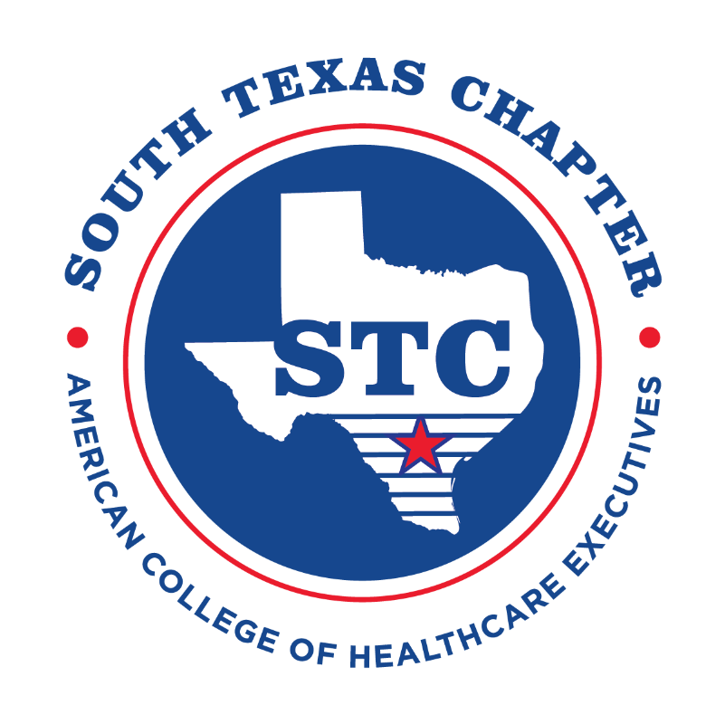  Want more information?  Contact:  Dr. Lorena Bailey  lorena_bailey@baylor.edu

