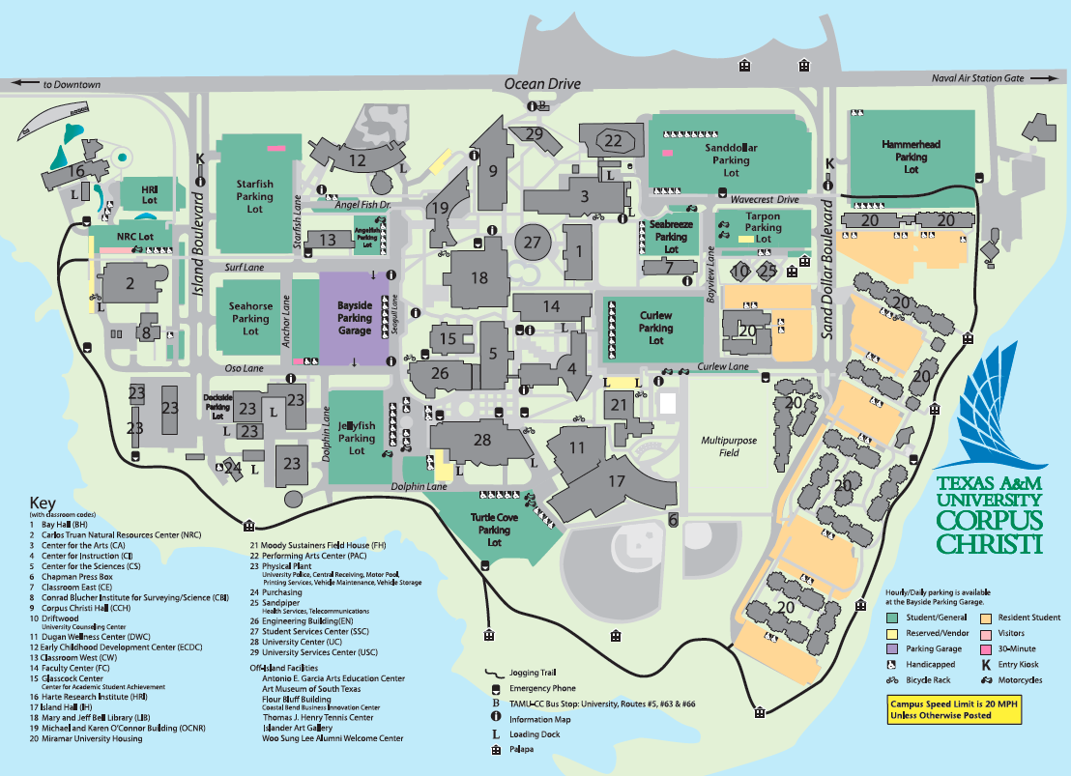
Enter campus at the first traffic light, Island Blvd, the first left past the guard booth takes you to the parking garage;
the second left takes you to the University Center. You may park next to the University Center or in the parking garage.
The parking garage is called Bayside Parking Garage. Exit the garage near the University Center, walk to the
University Center #28. There will be signs inside to help you find Lonestar Ballroom 142.

