Central & South Texas Chapters
Fall Collaborative
Friday, November 3, 2017
Texas State University
McCoy College of Business, Room #233
3.0 Face-To-Face ACHE Education Credits

1:00 PM-1:15 PM
- Welcome (Cristian Lieneck, Associate Professor, Texas State University School of Health Administration)
- Introductory Remarks (CT and ST-ACHE Chapter Leadership)

1:15 PM-2:45 PM PANEL #1- Integrating the Principles of Patient-Centered Care
Patient-Centered Care (PCC) has emerged as a way for healthcare organizations to achieve better quality and lower costs. This approach considers the patients’ cultural traditions, their personal preferences and values, their family situations, and their lifestyles. It makes the patient and their loved ones an integral part of the care team who collaborate with healthcare professionals in making clinical decisions and ensures that transitions between providers, departments and health care settings are respectful, coordinated and efficient. When care is patient centered, unneeded and unwanted services can be reduced. A truly patient-centered health care system may provide higher quality healthcare, improve patients’ experiences and increase efficiency.
Moderator: Karen Kendrick, RN, MSN, Director of Clinical Initiatives, Texas Hospital Association Foundation

Panelists: Christopher L. Pate, PhD MPA CQIA, Director of Quality and Performance
Improvement, CommUnity Care

Celina Padilla, BSN, RN, Division Director of Quality Mgmt, St. David’s

Elsie Graves, VP and Chief Nursing Officer, Central Texas Medical Center

Kim Miller, RN, MBA, Chief Quality Officer, CHRISTUS Santa Rosa

2:45PM-3:00PM Break (light refreshments provided)

3:00 PM-4:30PM PANEL #2 – Leading a Successful Multi-Generational Workforce
In today’s complex healthcare environment, a multigenerational workforce presents unfamiliar terrain for healthcare leaders. As a result conflicts may develop in healthcare organizations due to the generational differences in core values and work-related issues. Other factors include economic and political differences, size of each generation’s population, the transition of younger generations to leadership roles and social influences of the generational periods. This combination of factors results in further conflict among healthcare employees. Healthcare executives must take proactive steps to create cohesion across generational segments.

Moderator: Angela Jaco, MHA, MBA, FACHE, CEO, Hamlin Health Memorial Hospital

Panelists: Tony Sanchez, VP for Human Resources, Nix Health System

Tommye Austin, PhD, MBA, RN, NEA-BC, Sr. Vice President and Chief Nurse Executive, University Health System

David Parker, FACHE, Chief Operating Officer, Brooke Army Medical Center

4:30 PM Closing remarks – CT/ST ACHE chapter leadership
5:00 PM-7:30PM Networking reception at Salt Grass Steakhouse
221 E. Sessom Drive, San Marcos, TX, 7866 (Follow the attached map backwards and turn left into SaltGrass off Sessom Drive)

Central & South Texas Chapters

Registration information downloadable at:

http://centraltexas.ache.org/

http://stc.ache.org/

Ticket | Fee
Member Fee: | $40
Nonmember Fee: | $50
Life/Retired Affiliate Fee: | $20
Student Fee (full-time students with student ID): | $20

Note: Registration fee includes parking in the LBJ Student Center Garage, light refreshments during the break, the Salt Grass Restaurant reception, and a certificate of completion.
<<< CLICK HERE >>> TO REGISTER ONLINE
(Registration site/link is for both CT and ST chapter members)
*Registration available on Eventbrite only. No payments at the door please.*
Note: please email clieneck@txstate.edu with any ADA/accommodation requests at least 5 days prior to the event date.

For Questions or information please contact:
Jenifer Greenway- greenway.2.jq@gmail.com
Behnaz Asgar – Behnaz.asgar@gmail.com

Driving an | d Walking directions to Texas
State University McCoy Hall

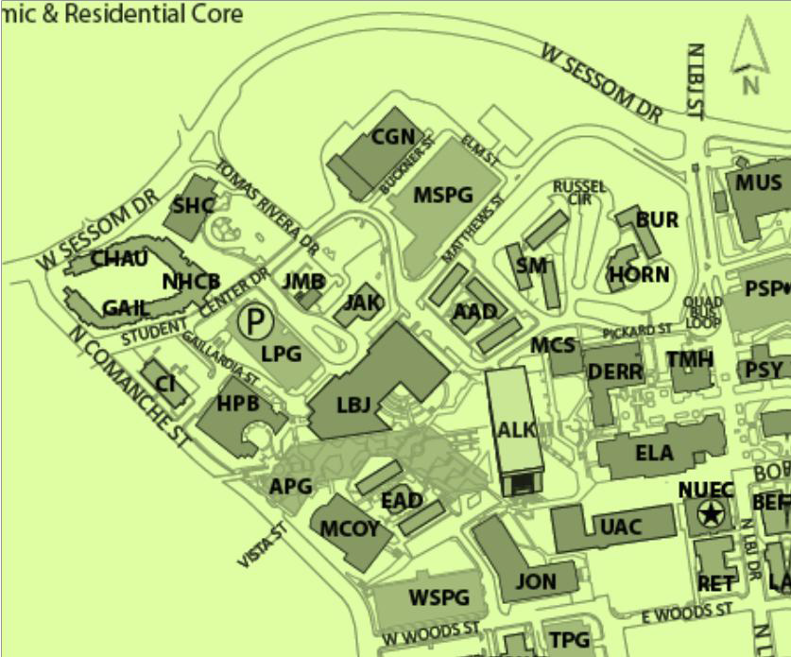
From the North (Austin) on IH-35:
Walking directions from LBJ Parking Garage (in red arrows):

- Proceed right out of the garage, towards the College of Health Professions building (HPB) for about 50 feet.

- Turn left at the Gallardia St. turn-around circle.

- Proceed straight approximately 1000 ft. to McCoy Hall. Enter on any
level and take the elevator to the 4th floor for lunch and event check-in.
McCoy Hall
Driving Directions (Indicated in blue arrows)
  - Take exit 206
  - Turn right on Aquarena Springs/University Drive
- Proceed through 1.3 miles and turn
right onto Sessom Drive
- Continue on Sessom Drive (up the big hill) and turn left at Comanche Street
- Turn Left on Student Center Drive
- Take the next right onto Gaillardia
Street
- The LBJ Parking Garage will be on your
left
From the South (San Antonio) on IH-35
- Take exit 206
- Turn left on Aquarena Springs/ University Drive
- Proceed through 1.4 miles and turn
right onto Sessom Drive
- Continue on Sessom Drive (up the big hill) and turn left at Comanche Street
- Turn Left on Student Center Drive
- Take the next right onto Gaillardia
Street
- The LBJ Parking Garage will be on your
left

Additional instructions:
- All attendees will want to allow for extra travel time to the event.
- Wayfinding signs will be posted in the academic mall to help navigate from the LBJ Parking Garage ticket office/counter to McCoy Hall.
- Free parking validation by the School of Health Administration – attendees parking in the LBJ Garage will be required to take a white ticket to enter the garage when arriving. The white ticket is not needed from this point further. A green ticket will be provided during the event, which is required to exit the garage at the end of the event.

